Laptop Request Catalog Item

|  |  |
| --- | --- |
| Date | 31 October 2025 |
| Team ID | NM2025TMID08347 |
| Project Name | Laptop Request Catalog Item |
| Maximum Marks | 4 Marks |

# Introduction

Employees in the organization need a quick and efficient way to request laptops for work. The current process is manual and prone to delays, with no dynamic form behavior to guide users or ensure accurate data collection. To address this, a Service Catalog item needs to be created, allowing users to easily request a laptop, with dynamic fields, clear instructions, and additional functionality like resetting the form if needed. The solution should also ensure all changes are tracked for governance and deployment.

# Key Features

* **Update Set** : Create or select an update set to track changes.
* **Service Catalog Item**: Create the laptop request item in the Service Catalog.
* **UI Policy**: Define UI policies to control form behavior
* **UI Action**: Add buttons or links (UI actions) for user interactions.
* **Export Update Set**: Export the update set after completing configurations.
* **Login to Another Instance**: Access a different ServiceNow instance
* **Testing**: Test the catalog item to ensure all functionality works as expected.
* **Conclusion**: Final thoughts or wrap-up.

**Pre-requisites**

1. Active **ServiceNow Personal Developer Instance (PDI)** obtained from developer.servicenow.com.
2. Basic familiarity with:
   * **ServiceNow navigation and configuration**
   * **Tables, forms, and related lists**
   * **Business rules and Flow Designer**

 GitHub or other repository (optional) for maintaining documentation and exported update sets

## Requirements Functional Requirements

* + The system must allow the creation of an update set to track changes made for the catalog item.
  + Users should be able to create a new catalog item specifically for laptop requests.
  + The item should include relevant fields such as model, purpose, justification, and approval.
  + Show/hide fields based on conditions.
  + Make fields mandatory or read-only.
  + Add actions like submit, reset, or cancel to the catalog item form for user interaction.
  + Ability to export the completed update set for transfer to another instance.

## Non-Functional Requirements

* + The catalog item form should load within 2 seconds.
  + Request submission should be processed without noticeable delay.
  + The catalog item form should be user-friendly and intuitive.
  + Field labels and help text must be clear and meaningful.
  + Only authorized users (e.g., IT Admins or Catalog Admins) should be able to create or modify the catalog item.
  + Data in the form should be validated to prevent injection attacks.

# Phases of the Project Ideation Phase

The **Ideation Phase** identifies the need to automate laptop requests using ServiceNow. Stakeholders discuss challenges with manual processes and propose a catalog item with dynamic forms and approvals. Key requirements are outlined, feasibility is assessed, and the idea is approved to move forward.

## Requirement Analysis Phase

* + Identify required fields (e.g., laptop model, justification).
  + Define user roles (requester, approver, fulfiller).
  + Document functional and non-functional requirements.
  + Set business rules and approval conditions.
  + Plan request workflow (submit → approve → fulfill).
  + Use ServiceNow components like Catalog Item, UI Policies, and Update Sets.
  + Validate and finalize requirements with stakeholders.

## Project Planning Phase

The team executed these milestones:

1. ServiceNow Instance Setup
   * Signed up at developer.servicenow.com and requested a Personal Developer Instance (PDI)
   * Filled necessary details; received instance access credentials via email
   * Logged in and prepared the instance for development.
2. Creation of Local Update Set
3. Access Navigation
   * Open ServiceNow and go to All → Update Sets.
4. Choose Local Update Sets
   * Select Local Update Sets under the *System Update Sets* module.
5. Create New Update Set
   * Click New to open the update set form.
   * Enter a meaningful name, e.g., "Laptop Request".
6. Save and Submit
   * Click Submit to save the new update set.
7. Activate the Update Set
   * After submission, click Make Current.
   * 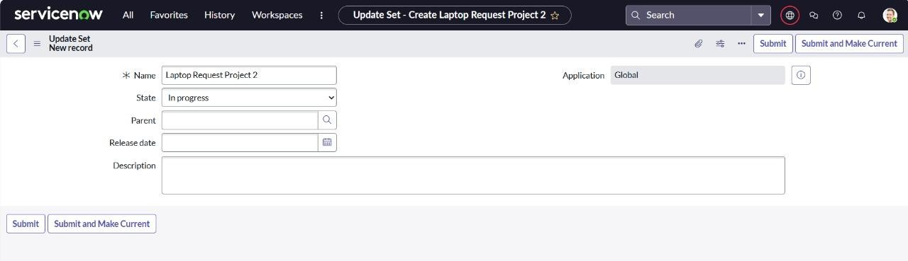This ensures all your changes are tracked under this update set.

## Create Service Catalog Item

1. Open service now.
2. Click on All >> service catalog
3. Select maintain items under catalog definitions
4. Click on New.

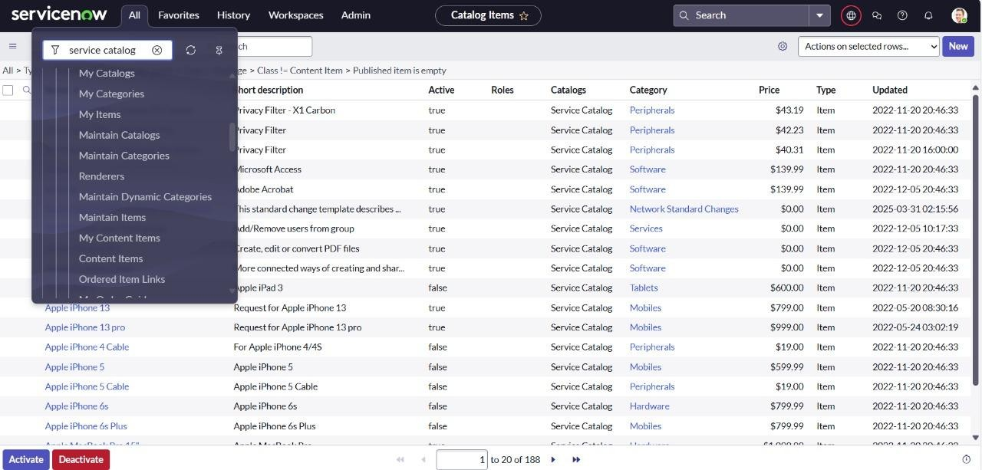

Fill the following details to create a new catalog item Name: Laptop Request

Catalog: service Catalog Category: Hardware

Short Description: Use this item to request a new laptop Click on ‘SAVE’

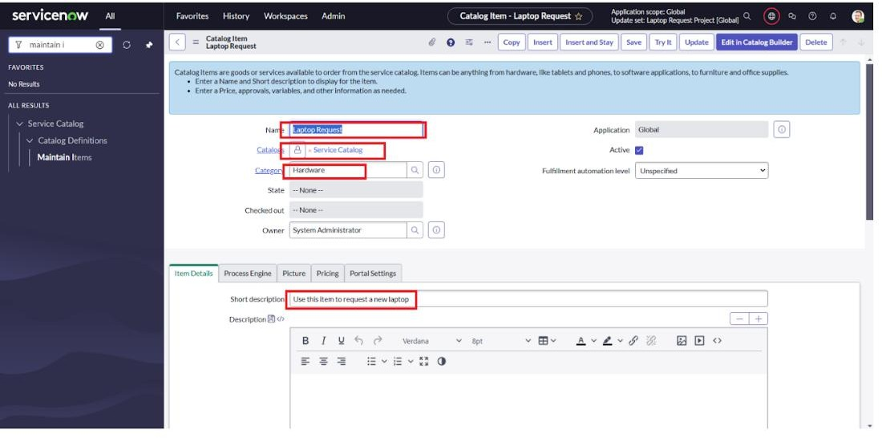

## Add variables Step1:

* + After saving the catalog item form scroll down and click on variable(related list)
  + Click on new and enter the details as below
    1. Variable 1:Laptop Model Type: Single line text Name: laptop_model Order:100
  + Click on submit

Again click on new and add Remaining variables in the above process

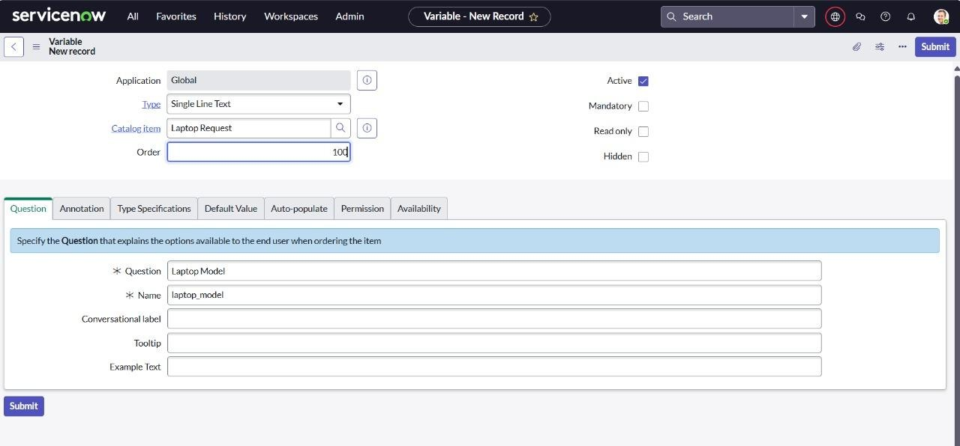

1. Variable 2:Justification Type: Multi line text Name: justification Order:200
2. Variable 3:Additional Accessories Type: Checkbox

Name: additional_accessories Order:300

1. Variable 4: Accessories Details Type: Multi line text Name:accessories_details Order:400

**Step2:**

* + After adding above variable which are added to newly created catalog item
  + Then save the catalog item form

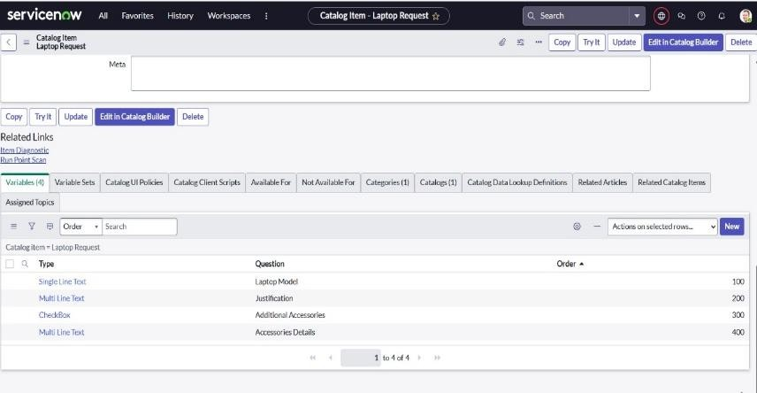

## Create Catalog Ui policies

1. Click on all>> search for service catalog
2. Select maintain item under catalog definition
3. Search for ‘laptop request’ which is created before
4. Select ‘laptop request’ and scroll down click on “Catalog Ui policies”
5. In the catalog ui policies related list tab click on new
6. Give short description as: show accessories details
7. Set the Catalog Condition in the related list tab ‘when to apply’ [field: additional_ accessories, operator: is, value: true]

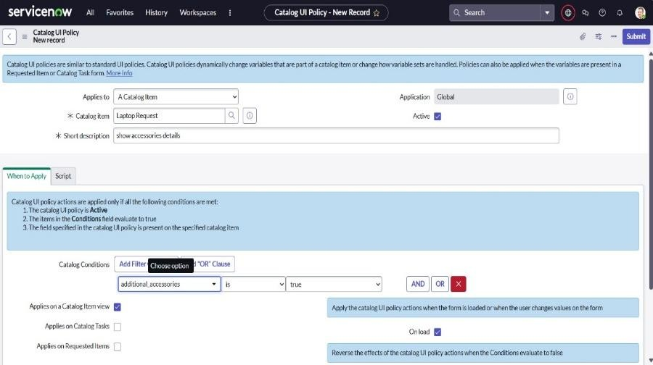

1. Click on **save**.(do not click on submit)
2. Scroll down and select ‘catalog ui action’
3. Then click on new button
4. Select variable name as: accessories_details

Order:100 Mandatory: True Visible : True

1. Click on save and again click save button of the catalog ui policy form.

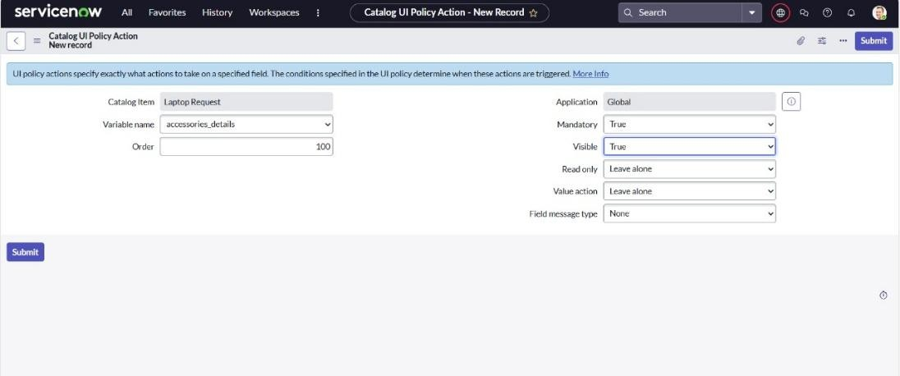

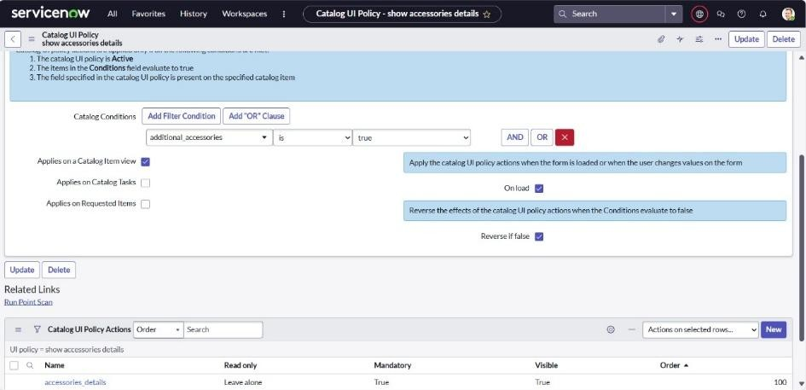

## Exporting changes to another instances

* 1. Click on All >> search for update sets
  2. Select local update set
  3. Select created update set i.e. ‘Laptop Request Project’
  4. Set the state to ‘Complete’
  5. In the related list Update tab, updates are visible which we perform under this update set.
  6. 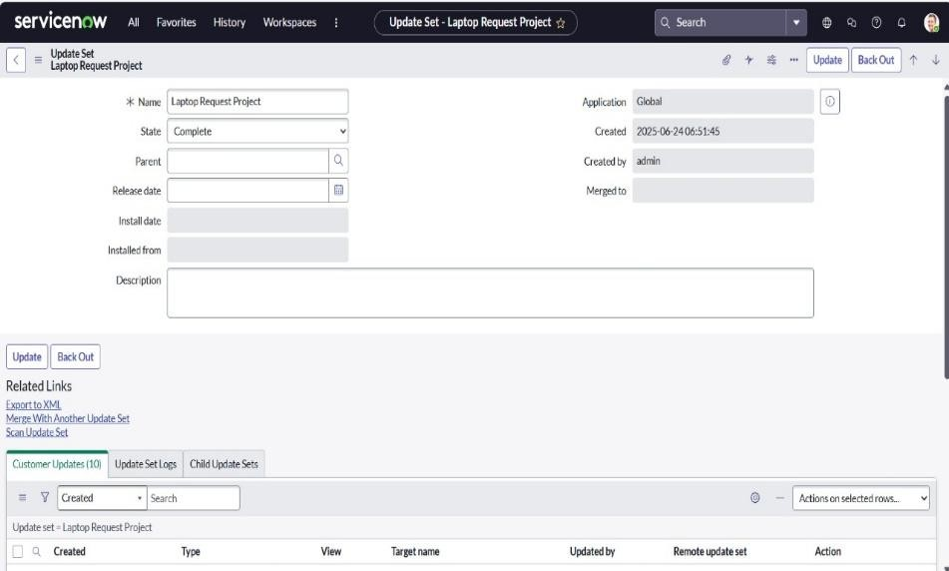Click on export to XML ,it download one file

**Retrieving the update set**

1. Open another instance in incognito window
2. Login with credentials
3. Click on all>> search for update sets
4. Select “Retrieved update set” under system update set
5. It open retrieved update set list and scroll down
6. 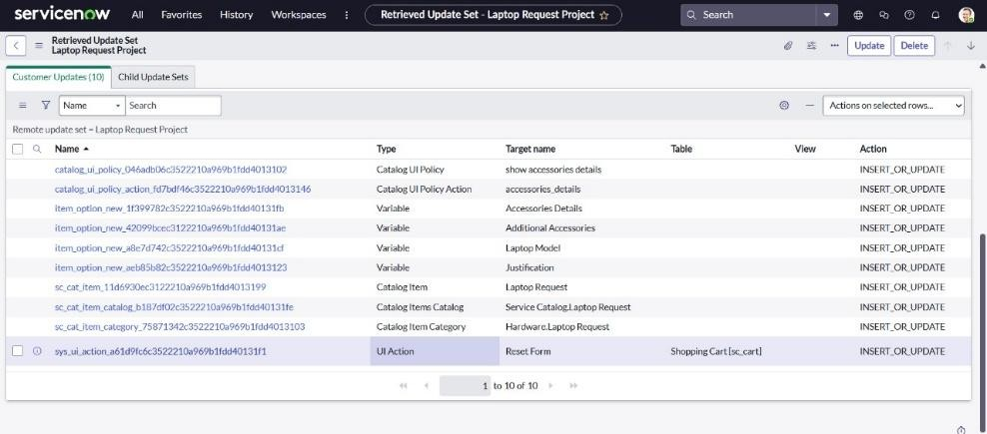Click on Import update set from XML
7. Upload the downloaded file in XML file
8. Click on Upload and it gets uploaded.

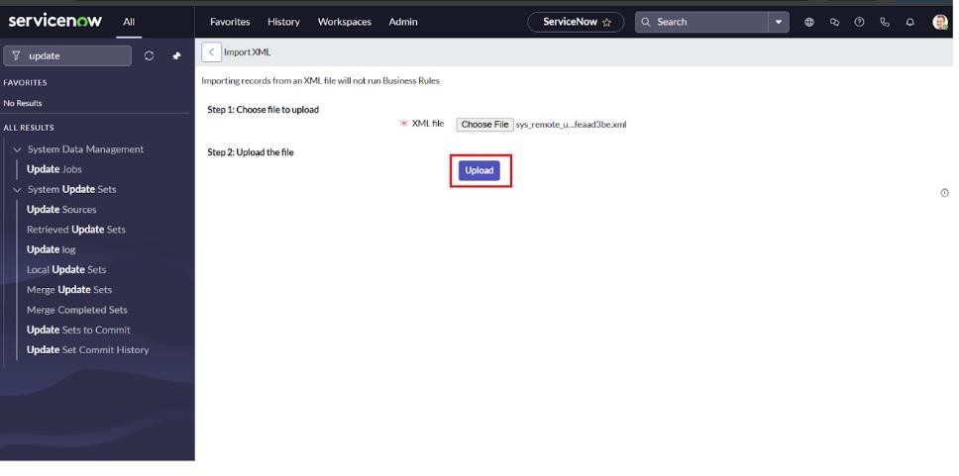

1. Open retrieved update set ‘laptop request project’
2. Click on preview update set
3. And click on commit update set
4. And also see the related tab updates
5. After commiting update set in this instance we get all updates which are done in the previous instance.

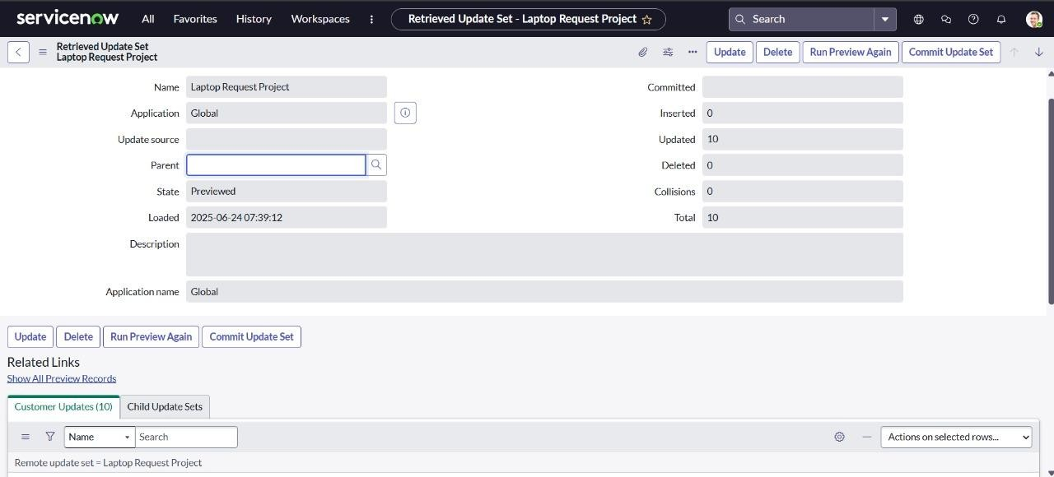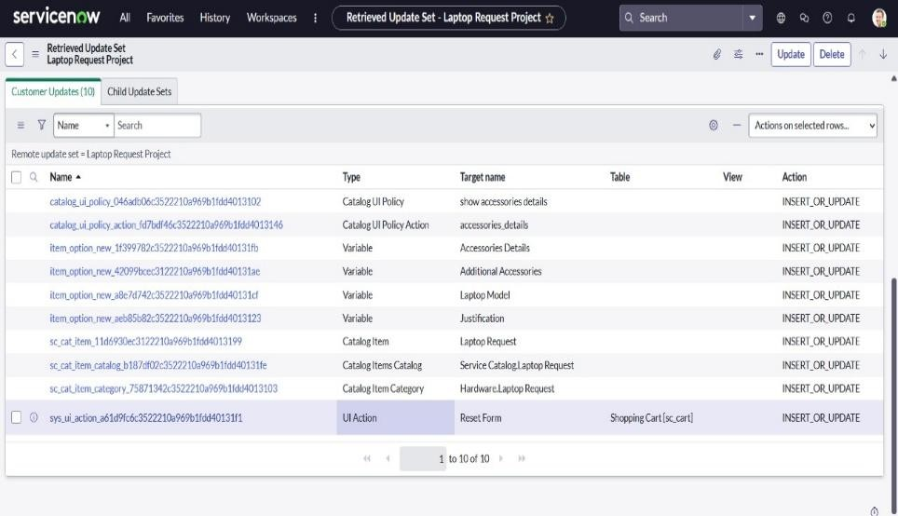

**Test Catalog Item**

1. Search for service catalog in application navigator in target instance
2. Select catalog under service catalog
3. Select hardware category and search for ‘laptop request’ item
4. Select laptop request item and open it
5. It shows three variables only.

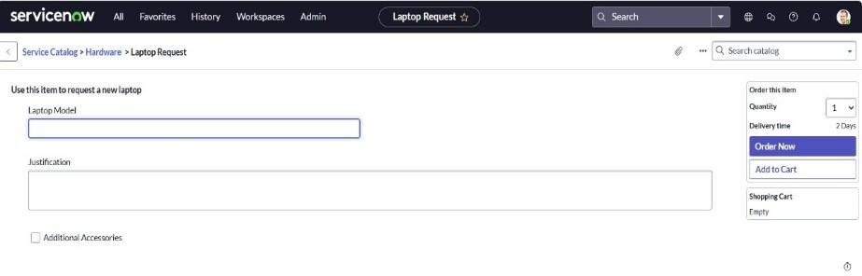

1. As per our scenario, when we click on additional accessories checkbox then accessories details fields is visible and that should be mandatory
2. Now see the results,it fulfills our requirements.

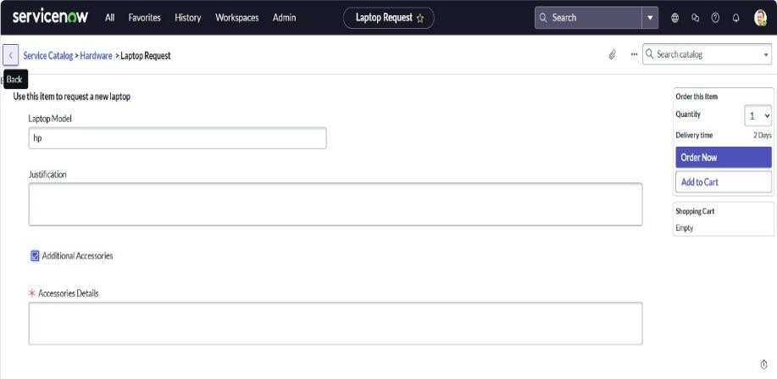

**Conclusion :**

The Laptop Request Catalog Item project successfully streamlines the process of requesting laptops within the organization by leveraging ServiceNow's Service Catalog capabilities. Through the implementation of a dynamic catalog item, the project ensures that users have an intuitive and user-friendly interface, reducing errors and improving efficiency.This project demonstrates how ServiceNow can be used to replace manual, error-prone processes with automated, efficient, and user-centric solutions. It not only improves service delivery but also enhances employee satisfaction by providing a modern and streamlined request experience.